**12**

**Here Documents**

**Objectives**

**· Take input between two tags and use it as input to a command**

**· Use a here document in a** commandfile

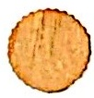

Notes

UNIX Shell Programming

© Copyright 1996-2000 GTRC, All Rights Reserved

**here Document**

**The Shell can be instructed to take input between two tags** anduseit as **standard input for the given command.**

**In the following example,! is the tag.**

command <<!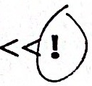

text

**-** **<<says take all of the text following the tag,!, up** tothenexttag,!,**that occurs on a line by itself and use it as input for the** command.

Notes

The string or tag following << is arbitrary.The document is terminated by a line that consists of the string or tag following <<.

The first character of the tag must start the line.

If the first tag is preceded by a "-", then the final tag can appear any place on the line providing only white space precedes the tag. The minus causes the leading white space to be stripped out of all lines of the here document.

Variable and command substitutions are made in the text before it is passed to the command.However,preceding the initial tag with a backslash will eliminate all substitutions.

**here Document Examples**

**· Example 1:**

$ cat substitute

**ed** $3 <<!

/$1/s//$2/

W

a

!

**1pr** $3 # or 1p 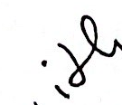 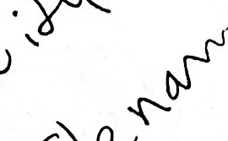

**·Example 2:**

$ substitute pong rice letter

**ed** letter <<!

/pong/s//rice/

W

q

!

**Ip or 1pr** letter



**Notes**

**here Document Examples (Cont'd)**

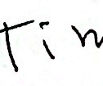

**· Example 3:**

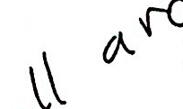 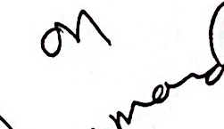 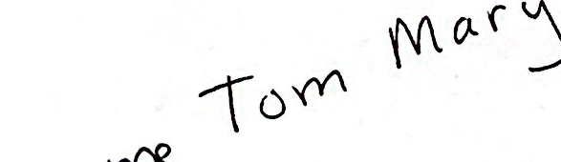

$ cat name

**for** i in $*

**do**

grep $i <<-%

Tom Jones Atlanta, GA

Mary Smith Washington, DC

% # The final tag can appear anywhere

# on the line as long as it is

# preceeded by whitespace or

# it can be the first entry on the line

**done**

**Example 4:**



1d 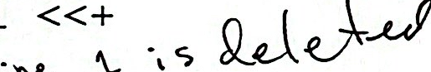

i 

$today

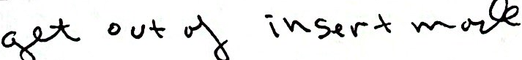

W 



+

echo "date changed"

**Notes**

The names listed on the command line are retrieved from the HERE document list.Note the use of -before the % tag.

**here Document Examples (Cont'd)**

**Example 5:**

**When you enter 5 numbers the program finds the average.**

dc <<-!2k 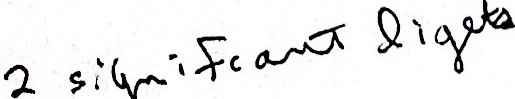

$1 $2 +

$3 +

$4 +

$5 +

$# /

p

q

!

**Example 6:**

**Computes the area and circumference of a circle when you enter the radius.**

echo "Enter the radius of the circle"

read r

area='

**dc** <<-%

5k



3.14159 *

P riut



$r 2 *

3.14159 *

P

a

%



**Notes**